♡空間を提供するカフェ♡

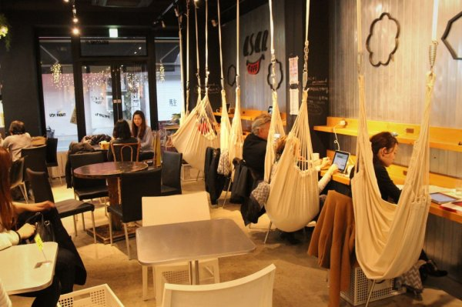j

**ハンモック**

<http://www.bing.com/images/search?q=%e3%83%8f%e3%83%b3%e3%83%a2%e3%83%83%e3%82%af%e3%82%ab%e3%83%95%e3%82%a7+&view=detailv2&id=79913C386D87C7B59343BFDFC6AA4A994B359635&selectedindex=12&ccid=p6tgi5KR&simid=608000111016675030&thid=OIP.Ma7ab608b9291534719b937560c23c062o0&mode=overlay&first=1>

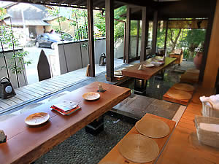

http://www.bing.com/images/search?q=%e3%82%ab%e3%83%95%e3%82%a7%e3%80%80%e8%b6%b3%e6%b9%af&view=detailv2&&id=179C2C9F4F5C3CC823C93E3F4CB8DAD45AB0E724&selectedIndex=0&ccid=t7jnSPH8&simid=608027693294355439&thid=OIP.Mb7b8e748f1fc193b3bf0508d4fd73437o0&ajaxhist=0



http://www.bing.com/images/search?q=%e3%83%97%e3%83%a9%e3%83%8d%e3%82%bf%e3%83%aa%e3%82%a6%e3%83%a0+%e6%9d%b1%e4%ba%ac&view=detailv2&&id=7E52064CE327B7030C4393FEB8F427C0689B179F&selectedIndex=20&ccid=mXc9qBi6&simid=608007768944020952&thid=OIP.M99773da818ba325d1322ffba0ebc5d9co0&ajaxhist=0